Ideation Phase

Brainstorm & Idea Prioritization Template

|  |  |
| --- | --- |
| Date | 26 June 2025 |
| Team ID | LTVIP2025TMID45878 |
| Project Name | Pattern sense:Classifying Fabric Patterns using Deep Learning |
| Maximum Marks | 4 Marks |

**Brainstorm & Idea Prioritization Template:**

**Step-1: Team Gathering, Collaboration and Select the Problem Statement** Before you collaborate

10 minutes to prepare

1 hour to collaborate

2–6 people recommended

Team Gathering:

Gather the required participants for the session and ensure they’ve received information or problem context.

Set the Goal:

The goal is to solve the problem:

“How can we effectively classify various fabric patterns using deep learning to aid in textile industry automation?”

Define Problem Statement:

“Fabric classification is a manual and error-prone task. How might we automate the recognition of fabric patterns (e.g., striped, checked, floral) using deep learning to increase efficiency in textile sorting?”

Key Rules of Brainstorming:

* Stay on topic
* Go for volume
* Encourage wild ideas
* Build on ideas
* Be visual if possible
* Listen to others

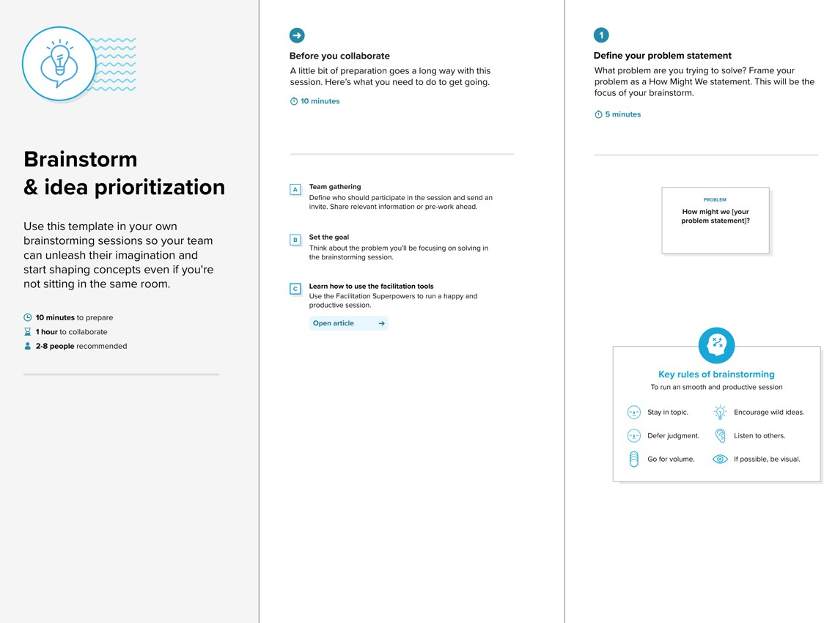

**Step-2: Brainstorm, Idea Listing and Grouping**

Brainstorm (20 mins):

Write down as many ideas that come to mind that address your problem statement:

* Use a CNN-based image classifier trained on labeled fabric patterns.
* Data augmentation for underrepresented patterns (e.g., abstract designs).
* Use attention-based models for texture-focused recognition.
* Apply transfer learning with pre-trained ResNet or EfficientNet.
* Build a mobile app for real-time fabric identification using camera input.

Group Ideas (30 mins):

Group similar ideas to form clusters such as:

* Data Collection & Preprocessing
* Model Architecture
* User Interface Integration
* Industrial Deployment Feasibility

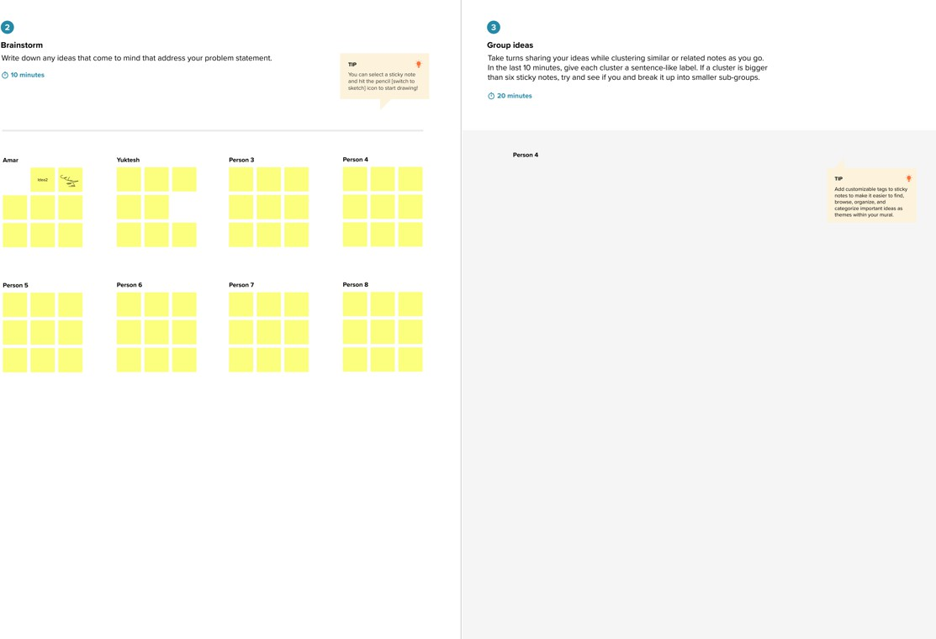**Step-3: Idea Prioritization**

Prioritize (30 mins):

Place your ideas on a 2x2 grid to determine which ones are important and feasible to focus on.

Axis | Description

------------|------------------------------------------

Importance | How well the idea solves the main problem Feasibility | Can we realistically implement this idea

Example grid placement:

* High Importance, High Feasibility: CNN with transfer learning
* High Importance, Low Feasibility: Real-time edge device deployment
* Medium Importance, Medium Feasibility: Mobile app interface

